QUOTATION
TO WHOMSOEVER IT MAY CONCERN

Sl. No. | PARTICULARS | PROFESSIONAL FEES | GOVT FEE
1. | Filing of Form 26 to take authorization to represent at the Patent Office. | 0 | 320
2. | Filing Fresh Form 1 and Form 5, if needed with petition | 0 | 1600 (u/r 137) or 10,000 per month (u/r 138)
3. | Filing Form 6 and doing Assignment deed | 5000 | 800
4. | Filing an affidavit and Form 13 to add an inventor | 2000 | 800
5. | To file Form 18 to file Request For Examination | 2000 | 4000
6. | To Analyze requirement of any data about Technical Significance/ Synergistic Effect and ensure compliance of the same with discussion with inventors | 8000
7. | Furnishing the Information to the Patent Office in an affidavit regarding Technical Significance/ Synergistic Effect | 8000
8. | Filing Form 8 to include inventor names on the certificate | 2000
9. | Address the Objections of FER | 15000
10. | Filing Form 30 to notify the controller regarding attending the hearing | 3000 | 1500
11. | Attend the hearing and provide written submission till grant | 20000
 | TOTAL | 65000 | 19020
 | GST | 11700 | 0
 | STAMP DUTY | 0 | 3000
 | GRANT COST TO THE UNIVERSITY | 76700 | 22020
 | GRANT COST TO THE UNIVERSITY | 98720


For An Astraea Research Innovative Solution,
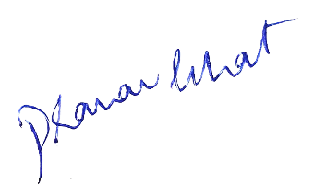

Adv. Pranav Bhat
Chief IP Strategist and Managing Partner
Date: 15th October 2024
Place: Bengaluru

